Assignment 27.4

Problem Statement

Run parallel jobs in hive by following the steps in the below blog link

Creting 4 tables and loading the datasets in them.

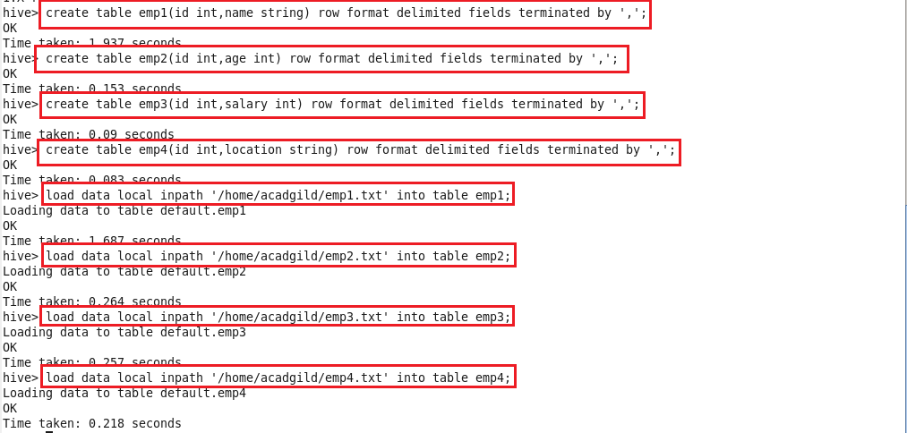

Displaying the contents of the 4 tables.

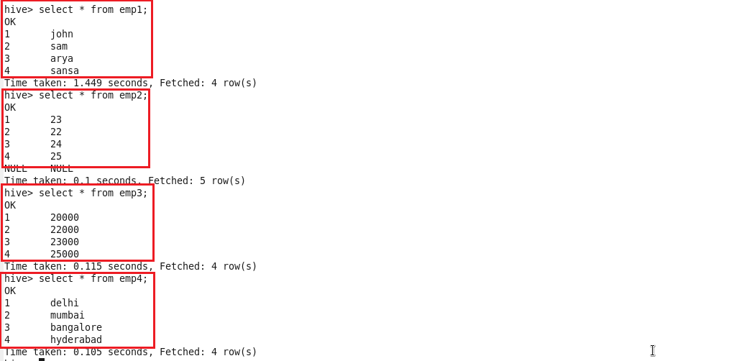

Running parallel jobs

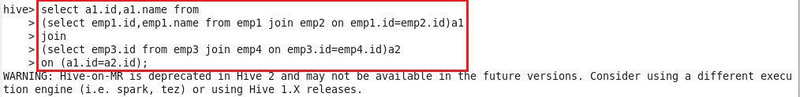

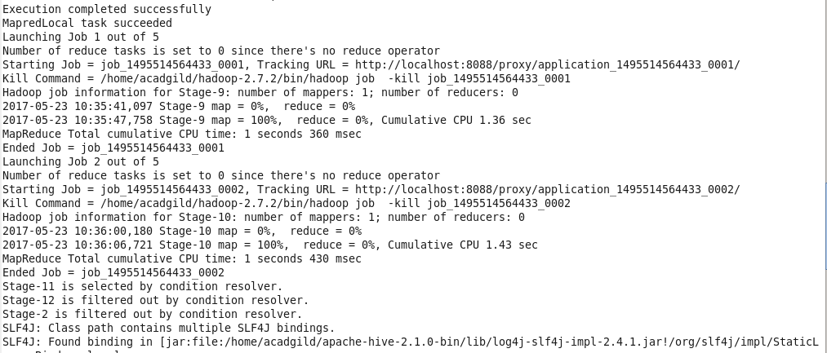

Output

